Assignment 2:

After downloading the data, I converted each file to a csv so it could be interpreted by Tableau. The data did not have column/attribute names so I reviewed the additional files from the UCI website to determine the attribute names and classifications. This helps so that I can edit the names of the columns and even change the data-type (string vs integer and discreet vs continuous). For purposes of this assignment, I did not alter the data at all (other than renaming the columns). In a real-world case, I would change some of the values from single letters to their full name, and change some values that are zeros or null to something specific—I know that sometimes zeros can mess with numerical data even though it’s just a placeholder for lack-of-data.

IRIS:

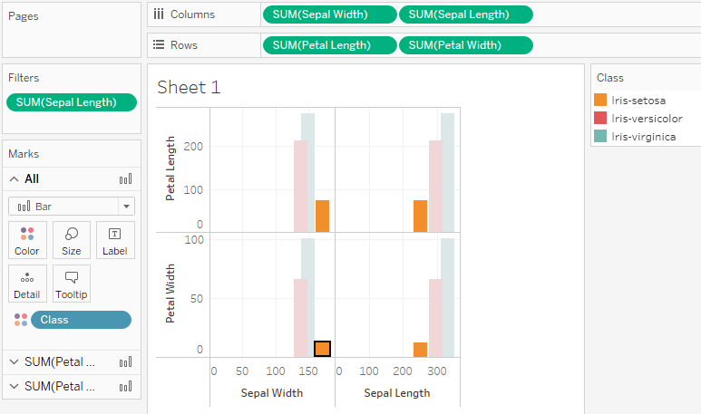

The Setosa has the shorted Petals and Sepals, while Virginica has the longest of each. Here, I tested using different combinations of the data as attributes under “Dimensions” and “Measures” to come up with clearly interpretable layout.

CARS:

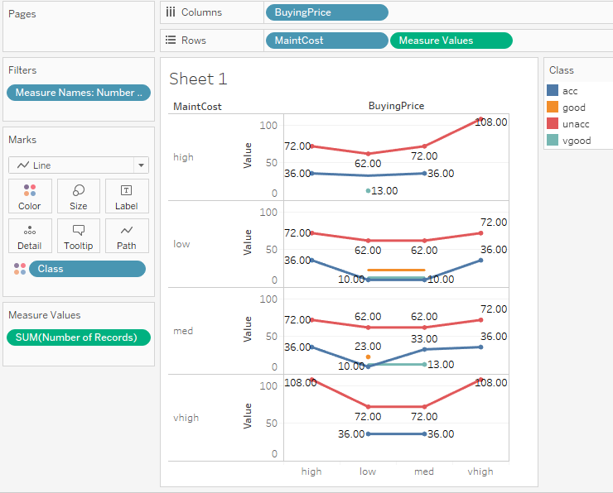

Shows the car class within the Buying Price versus the Maintenance Costs. This was difficult to navigate results between using count distinct (COUNTD), count (COUNT), and using the sum of values. I’d like to learn more about ways of quantifying data or calculating correlation between variables.

MUSHROOMS:

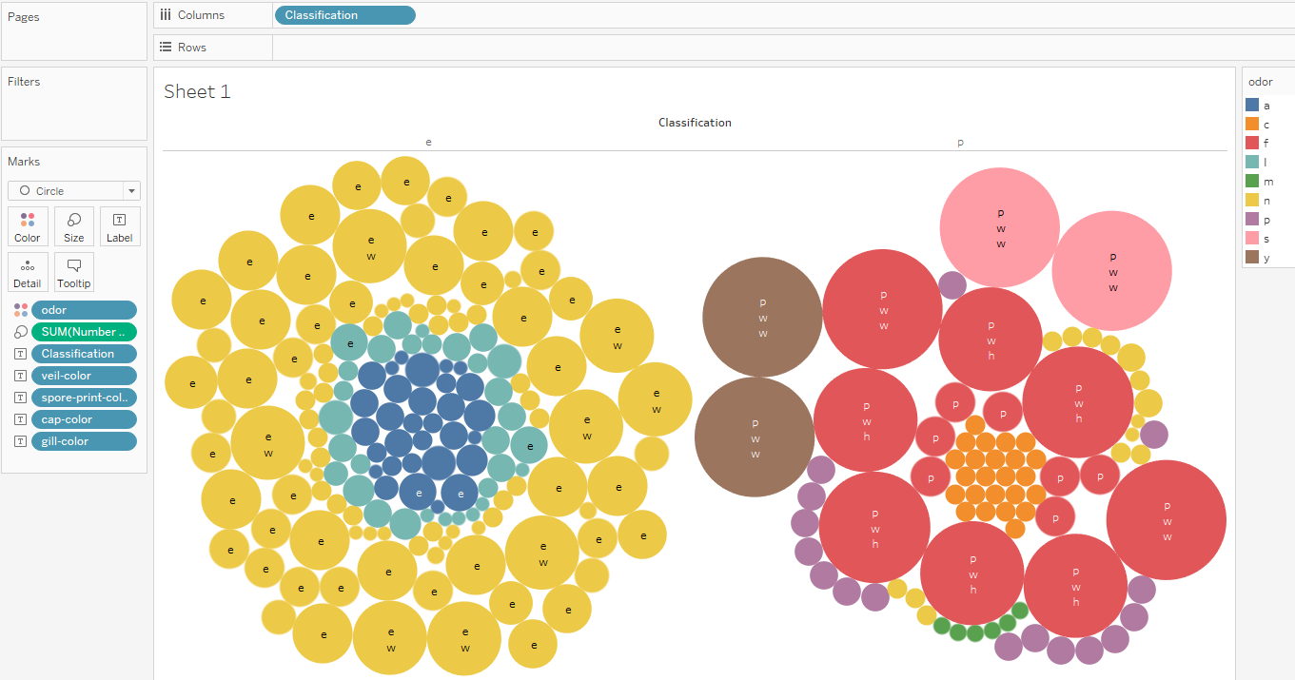

In this one I utilized the “Show Me” button in the top left and played around with a number of combinations of color-specific attributes of the data. Finally, I used “Odor” as the color scheme and categorized between edible and poisonous mushrooms. I think this would be more effective if the data were updated to include the actual values of the different attributes rather than the letters.

CENSUS:

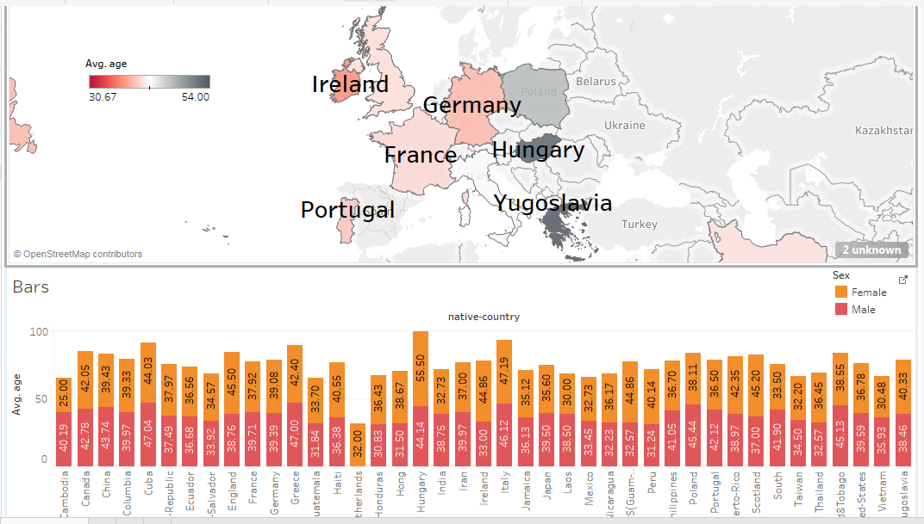

Using the census data, I created a dashboard with a map and bar chart centered around average age. The top visual is a map, zoomed in, with countries more clearly labeled, with average age as a gradient. You can see that France and the UK have a younger working class while Hungary and Yugoslavia’s average working class is older. The bottom chart adds in the dimension of sex for the countries. I still need to play around with the view (to show everything on one screen) and it took some manual edits of the country names so that Tableau could interpret within it’s geo-capabilities.